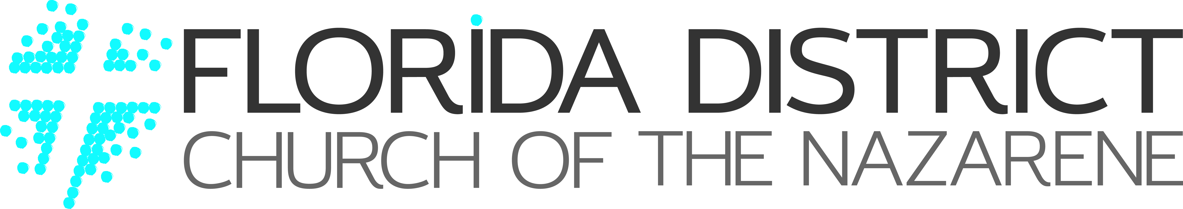

November 14, 2023

Team Florida Pastors,

As we get ready to turn the calendar on another year, I wanted to share with you a Countdown to District Advance 2024 that you can use to help make caring for the end of your church year a whole lot easier.

I’ll also send this out in my December Monday Pastors’ Email, but just in case you don’t get the email I wanted you to have a copy in print.

I’ve heard from many of you that this Countdown to District Advance really helps you stay on top of your preparation, so I wanted to get it into your hands right at the start of the new year.

Pastor, thank you for all you have done to lead your congregation well over the past year.

I just received a report the other day that we’ve now exceeded over 600 baptisms for the year, and we’re only 2/3^{rds} of the way through the Church Year! What a great year of ministry it’s been already. You’re leadership and the ministry of your congregation is truly making an eternal difference!

As you prepare for 2024, the Florida District Resource Center Team is here to help you in any way we can as you lead your congregation through this season of ministry. If there is anything we can do to assist you, please let us know by email or by calling (863) 644-9331.

Watching, waiting, and yearning,

Rev. Dale W. Schaeffer || District Superintendent

